## Step to Install Camtasia 2019:

This setup installation does not contain user defined libraries and only contains system defined libraries.

1. Install vc_redist.x64
2. Install camtasia_2019_setup_2019.0.8

password : chitresh

1. if error : codec not found

Then execute : exe in codecs folder

Download these codecs from :-

<https://www.techsmith.com/codecs.html>

this link will work in Internet Explorer

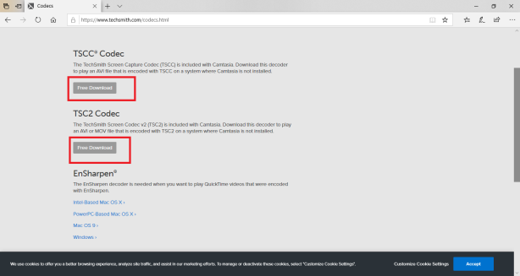

1. For Activation : This installer install camtasia which is already activated. But if it gets deactevated then :-

Just copy file : - "RegInfo\RegInfo.ini"

Paste into :- “ProgramData\TechSmith\Camtasia Studio 19\RegInfo.ini”

Start Camtasia